Dynamic Data Masking in SQL Server 2016 Author: Atul Gaikwad

http://www.sqldbaexperts.com/dynamic-data-masking-in-sql-server-2016/
Problem: I am sure most of you have come across this situation where you will have to secure your PII data and you will have to go through series of tasks for implementing Database Encryption or any other solution like this, which is pretty complex and overhead to manage. While it comes to migration it is nightmare, if you loss encryption key or loss the encryption password then there is hardly any way to recover your encryption setup and you will have to start from scratch in 90% cases. What if you get a magic wound which can secure all your PII data and manage it for you so that you will have good night sleep. Let’s see how to get a magic wound, I mean how we can achieve this with SQL Server 2016 new feature i.e. Dynamic Data Masking.
Solution: Microsoft has come with lot of interesting features with SQL server server. For detail of the various new features in SQL server 2016 please refer my blog: Link
I am not going to cover in details about what is masking and why we need it but I am going to demonstrate how you can mask the data while you create a table or how you can mask data on existing table. For details please refer at Microsoft site.
Please note that, for dynamic masking you don’t need special permission on the database but only CREATE TABLE and ALTER permission on the schema is required and for modifying masking you need ALTER ANY MASK permission. And for users you want to view mask data you should grant UNMASK permission.
So lets create a new table with masking enabled.
- CREATING DATA MASKING:
CREATE TABLE UserInfo
(UserID int IDENTITY PRIMARY KEY,
FirstName varchar(100) MASKED WITH (FUNCTION = 'partial(1,"XXXXXXX",0)') NULL,
LastName varchar(100) NOT NULL,
Phone# varchar(12) MASKED WITH (FUNCTION = 'default()') NULL,
Email varchar(100) MASKED WITH (FUNCTION = 'email()') NULL);

INSERT UserInfo (FirstName, LastName, Phone#, Email) VALUES
('Shushant', 'Singh', '989.100.1234', 'SSingh@SQLDBAExperts.com'),
('Maria', 'Fernandis', '989.100.1235', 'MFernandis@SQLDBAExperts.com'),
('Zoya', 'Rastogi', '989.100.1236', 'ZRastogi@SQLDBAExperts.com');
SELECT * FROM Userinfo;

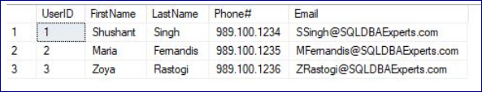
Lets create a dummy user to verify if the masking is working:
2. CREATING TEST USER:
CREATE USER TestUser WITHOUT LOGIN;
GRANT SELECT ON UserInfo to TestUser

EXECUTE AS TestUSER = 'TestUser';
SELECT * FROM UserInfo;
REVERT;
Now you will see data is masked as below:
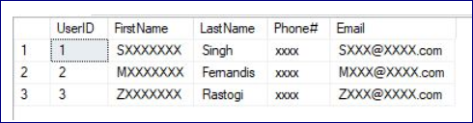

3. Adding or Editing a Mask on an Existing Column:
you can use ALTER command to add masking on the column in the table or modify the masking on column:
Below command will add masking on the LastName column:
ALTER TABLE UserInfo ALTER COLUMN LastName
ADD MASKED WITH (FUNCTION = 'partial(2,"XXX",0)');
This command will change the masking function on the LastName column:
ALTER TABLE UserInfo ALTER COLUMN LastName
ALTER COLUMN LastName varchar(100) MASKED WITH (FUNCTION = 'default()');
4. GRANT PERMISSION TO VIEW UNMASKED DATA:
Let’s grant view unmask permission to TestUser:
GRANT UNMASK TO TestUser;
EXECUTE AS USER = 'TestUser';
SELECT * FROM USERInfo;
REVERT;
-- Removing the UNMASK permission
REVOKE UNMASK TO TestUser;

5. DROP DYNAMIC MASKING:
Finally, Let’s see how you can drop masking from existing column:
ALTER TABLE UserInfo
ALTER COLUMN LastName DROP MASKED;
Please go ahead and test this in your environment and Let me know if you face any challenges or issues. As well please do let me know your comments and share the knowledge in the community if you like this blog or found it useful.

